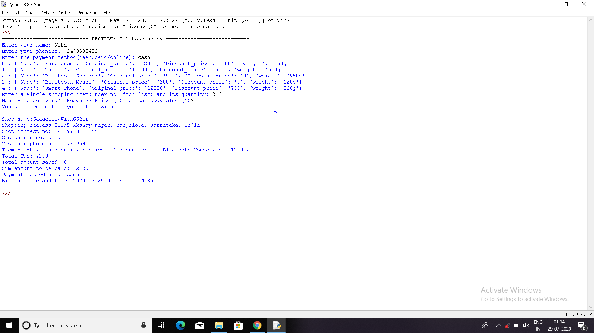

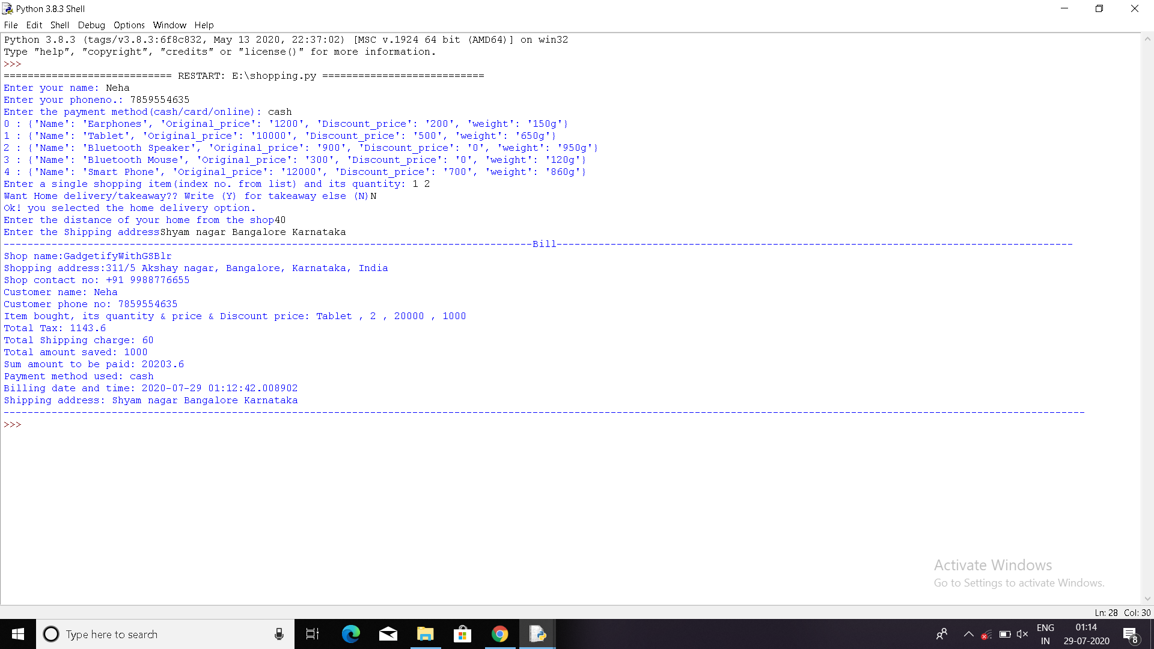

The Shopping cart easy problem has been solved using python , in it I have used dictionary to store the items that a person can buy . The person has to simply write the index no. from the list (index no. starts from 0) and should also mention the quantity he/she wants to buy .

The program written will automatically calculate the bill including the tax , the amount he/she saves and also show the product and its quantity bought at what time.

The problem also has the option of delivering items ..